**A CRM APPLICATION FOR LAPTOP RENTALS**

**1. Project Overview**

 This project is focused on the CRM Application for Laptop Rentals, designed to address the challenge of optimizing the rental process and enhancing customer interactions. The goal is to deliver a comprehensive solution by leveraging customer relationship management principles and advanced technology. Through this project, we aim to enhance operational efficiency and user experience and support the long-term goals of the rental service business.

**2. Objectives**

**Business Goals**

* Increase Customer Acquisition: Attract new customers through enhanced marketing strategies and personalized communication.
* Improve Customer Retention: Foster loyalty by providing exceptional service and tailored rental experiences.
* Optimize Operational Efficiency: Streamline rental processes to reduce turnaround time and minimize manual errors.
* Enhance Revenue Generation: Increase overall rental income by maximizing inventory utilization and offering competitive pricing.

**Specific Outcomes**

* A fully functional CRM system that centralizes customer data, automates communication, and manages rental transactions efficiently, resulting in improved customer engagement and streamlined rental processes.

**3. Salesforce Key Features and Concepts Utilized**

* Account and Contact Management: Centralizes customer data, providing a comprehensive view of customer interactions and history, which enhances personalized communication and service.
* Opportunity Management: Tracks sales deals and customer interactions throughout the rental process, allowing informed decision-making regarding follow-ups and engagement strategies.
* Automated Communication: Utilizes Salesforce’s automation capabilities to send personalized emails and notifications, ensuring consistent communication and timely follow-ups with customers.
* Data Management: Centralized storage of customer information allows easy access from any device, supporting effective data management practices and optimizing rental offerings based on insights.
* Reports and Dashboards: Provides robust reporting tools to track key performance metrics related to rentals, sales productivity, and customer satisfaction, facilitating data-driven decisions.
* Lead Management: Captures potential customer information efficiently, enabling the team to nurture leads through automated workflows and targeted marketing campaigns.

**4. Detailed Steps to Solution Design**

* 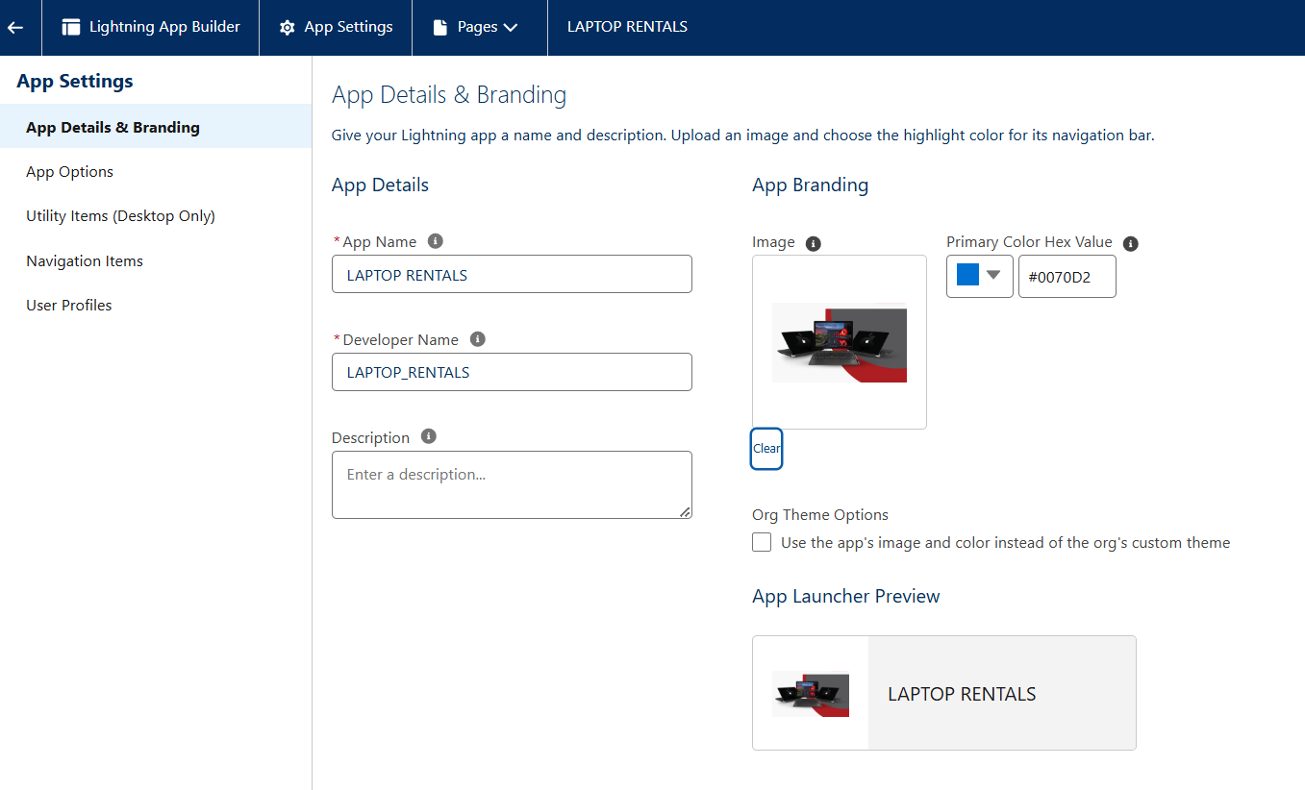  Lighthing App:  Central hub for accessing all rental functionalities.
* Fields : Displays and manages customer and rental data entries.

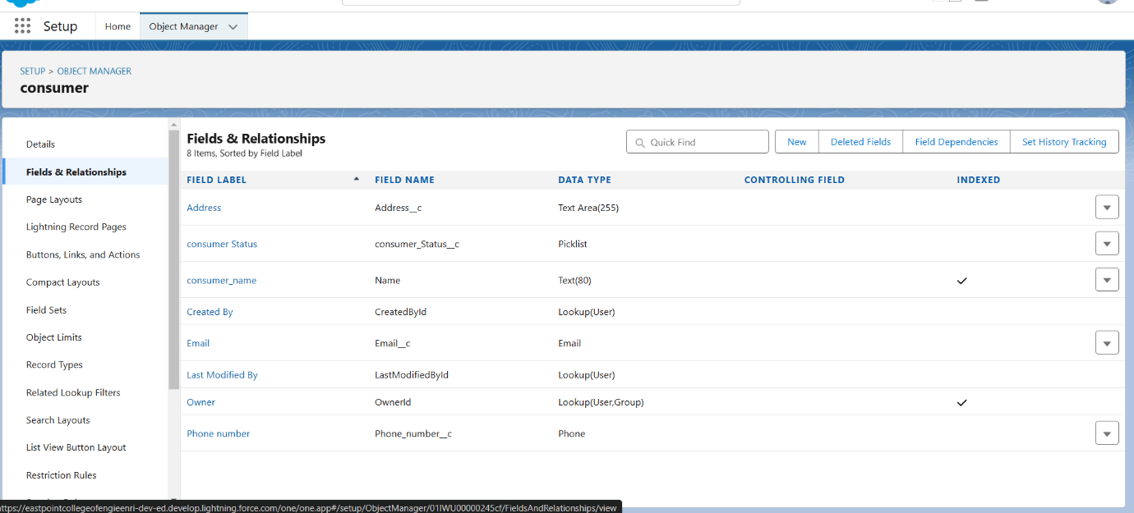

Consumer fields

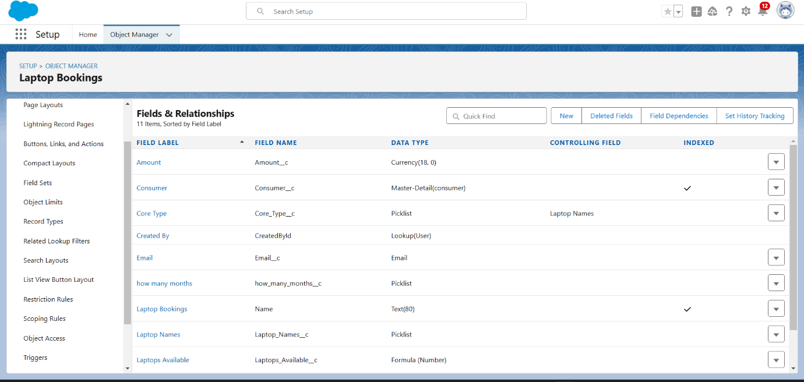

Laptop booking Fields

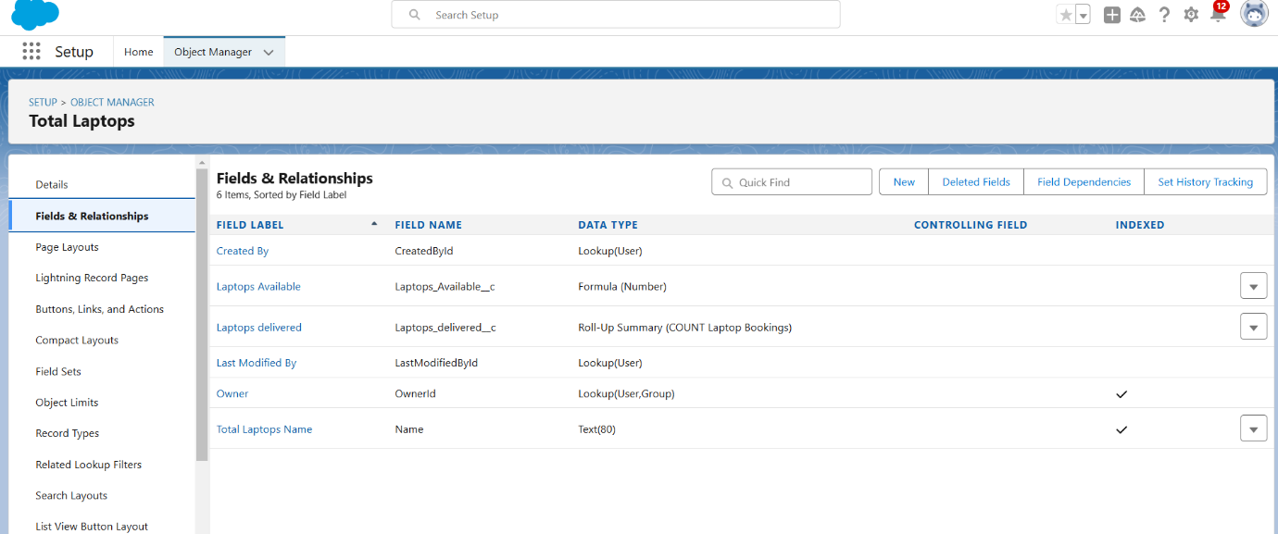

Total Laptops Fields

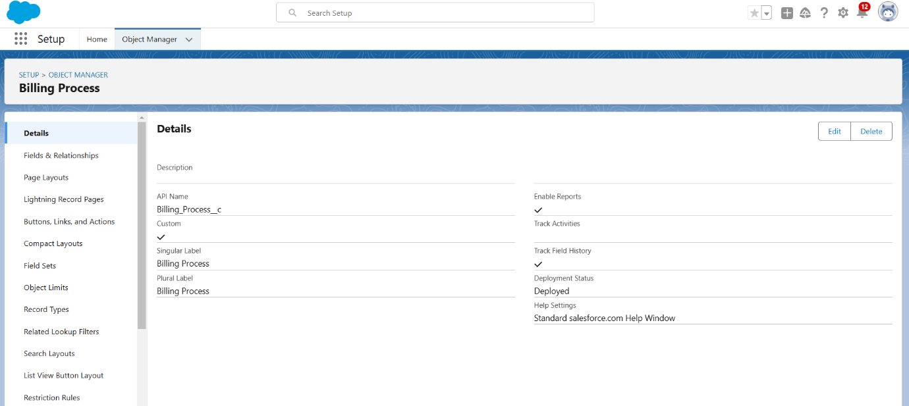

Billing Process Fildes

* Profile : Manages user profiles and permissions.

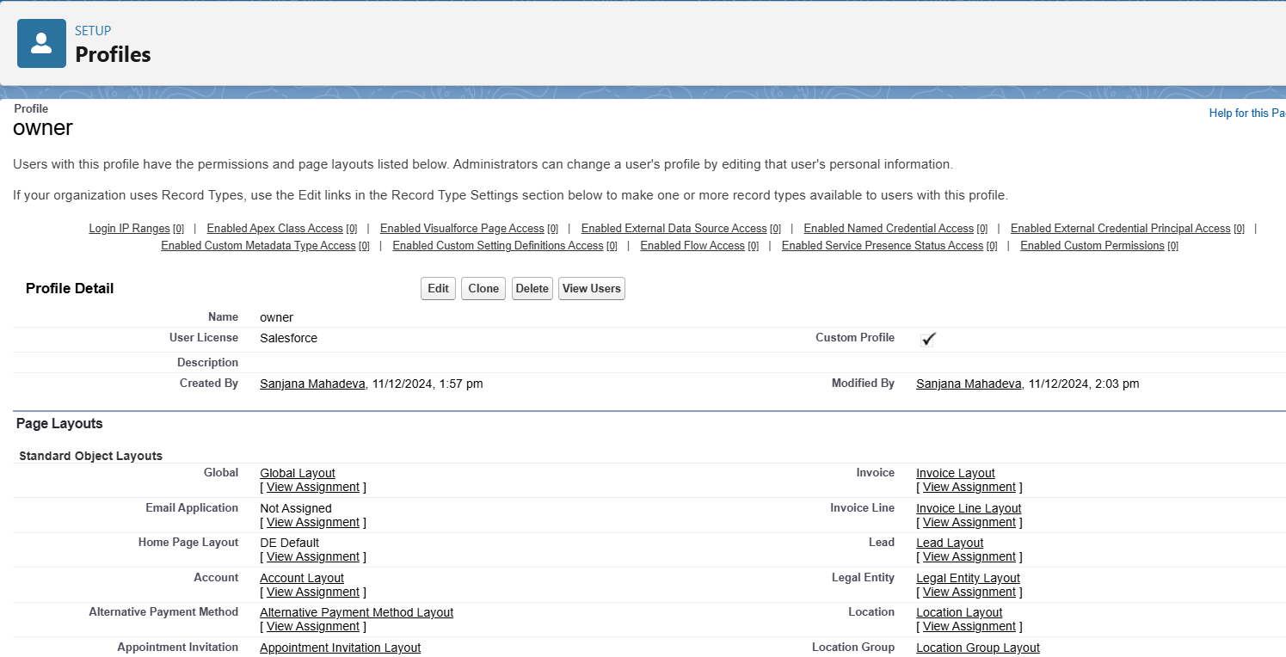

Owner Profile

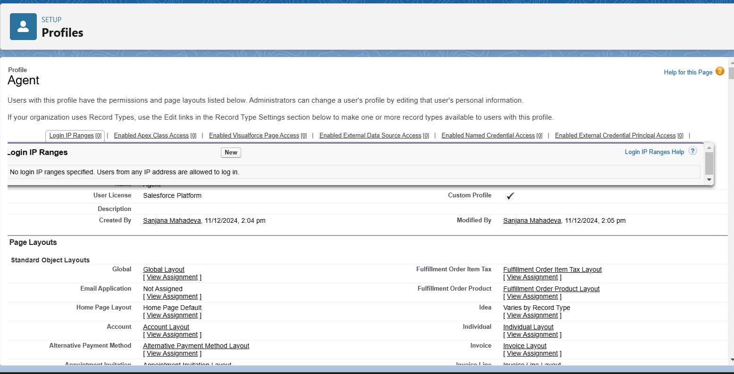

Agent Profile

* Roles : Defines user hierarchy and data sharing settings.

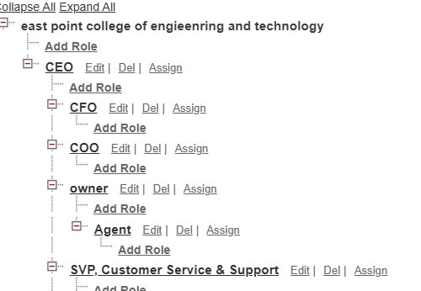

* User : Manages individual user accounts and permissions.

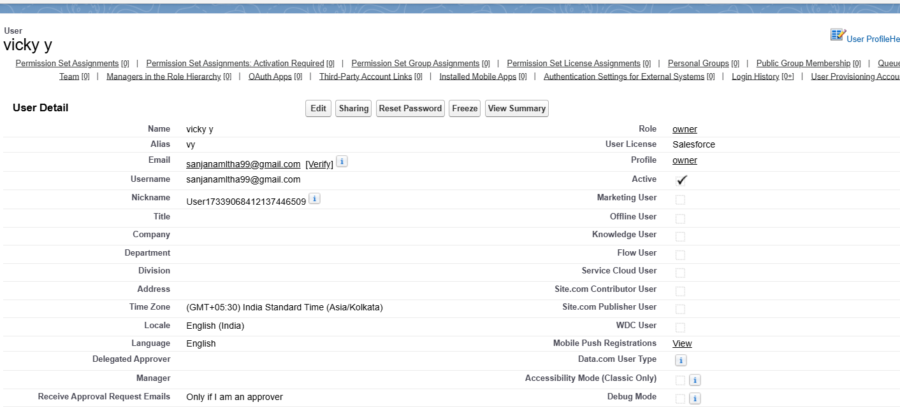

user 1

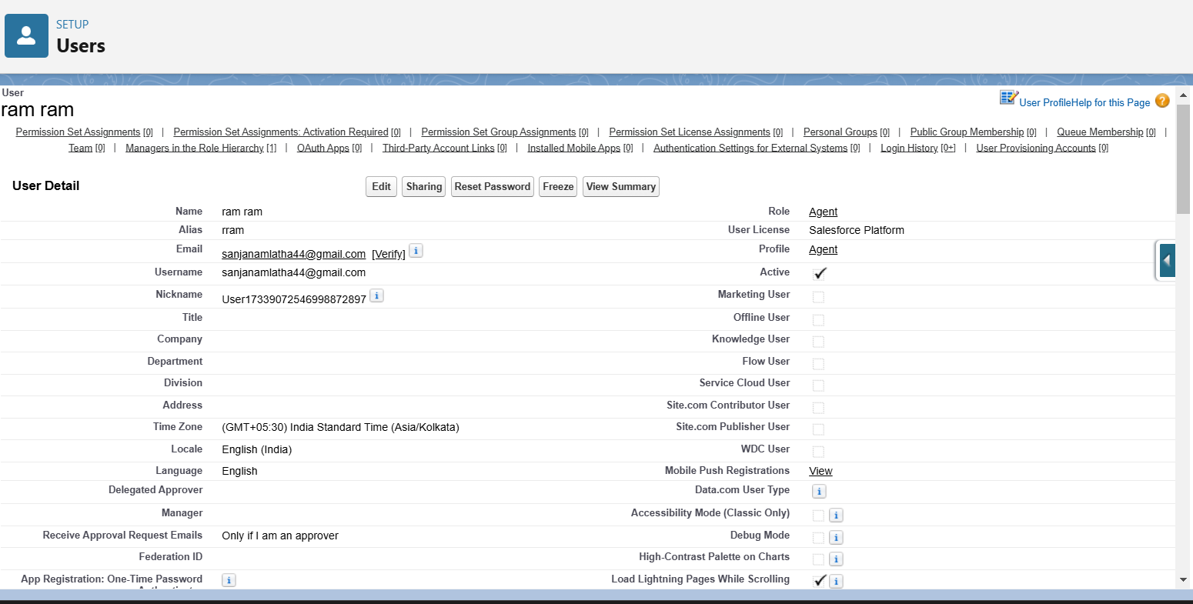

User 2

* Flows : Automates business processes and workflows.

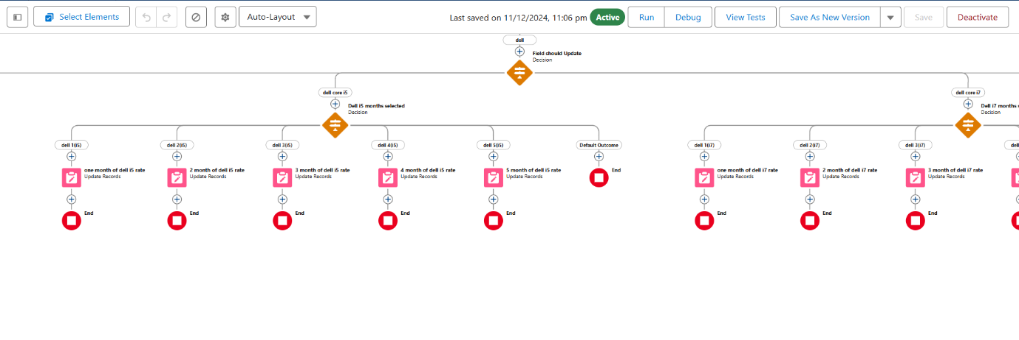

Dell flow

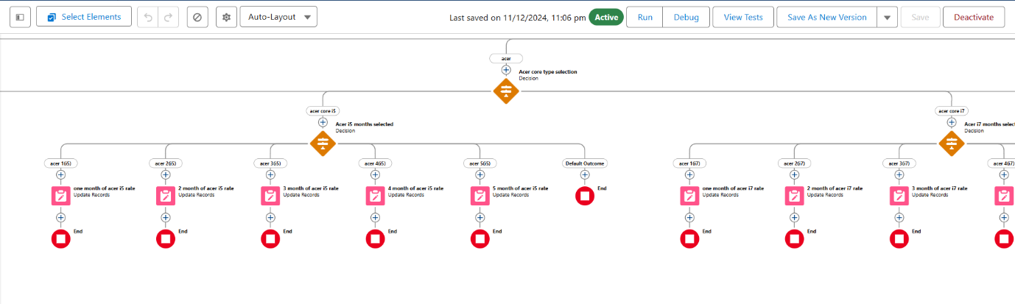

Acer Flow

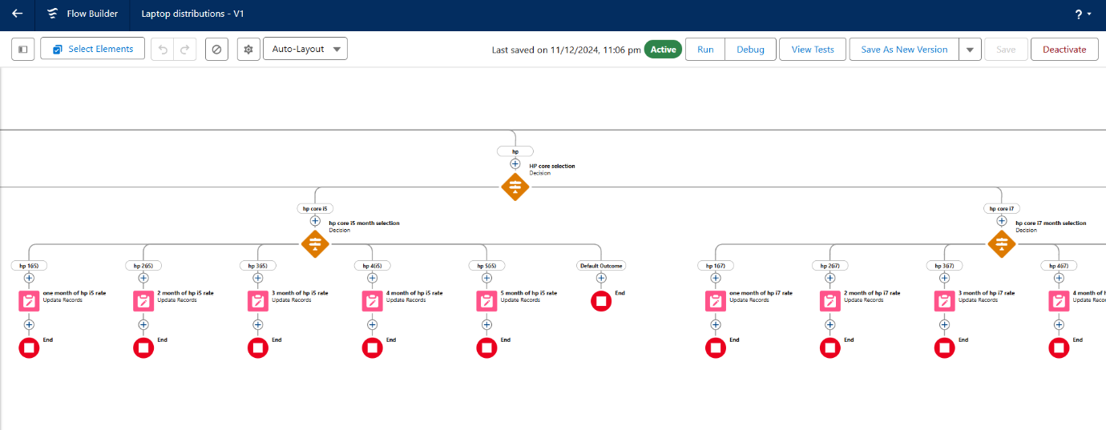

Hp flow

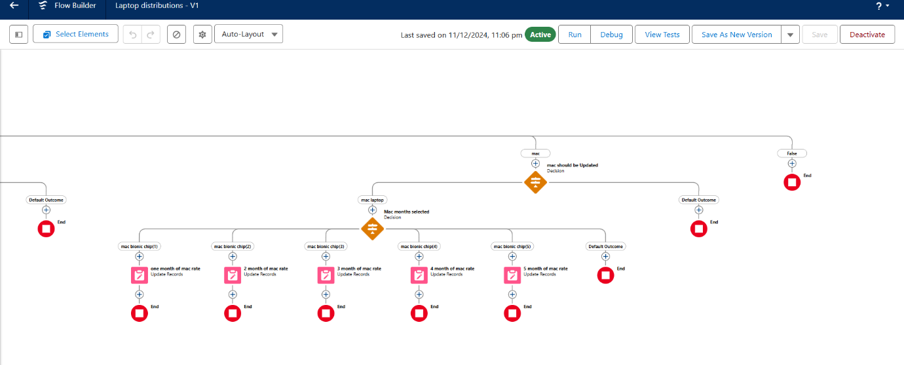

Mac flow

* Apex : Customizes application logic using Salesforce programming.

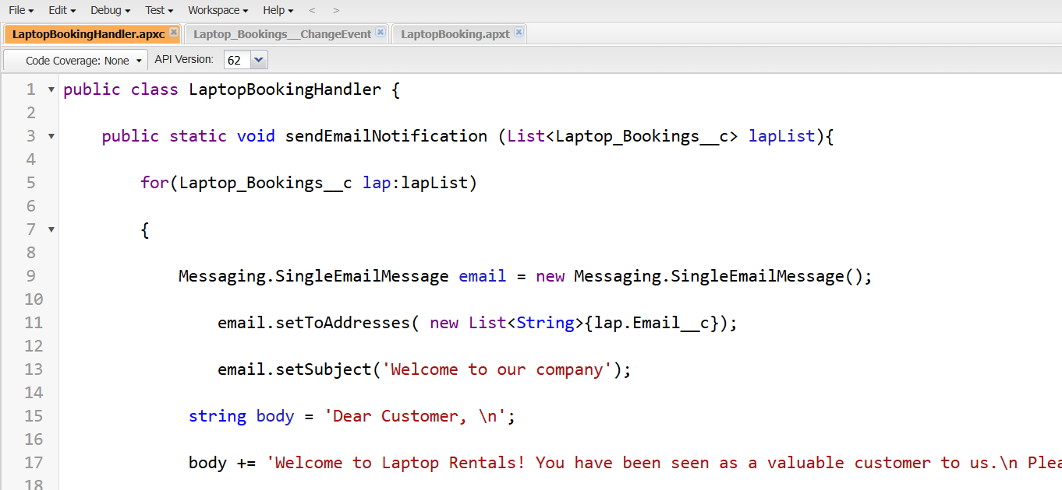

Apex class

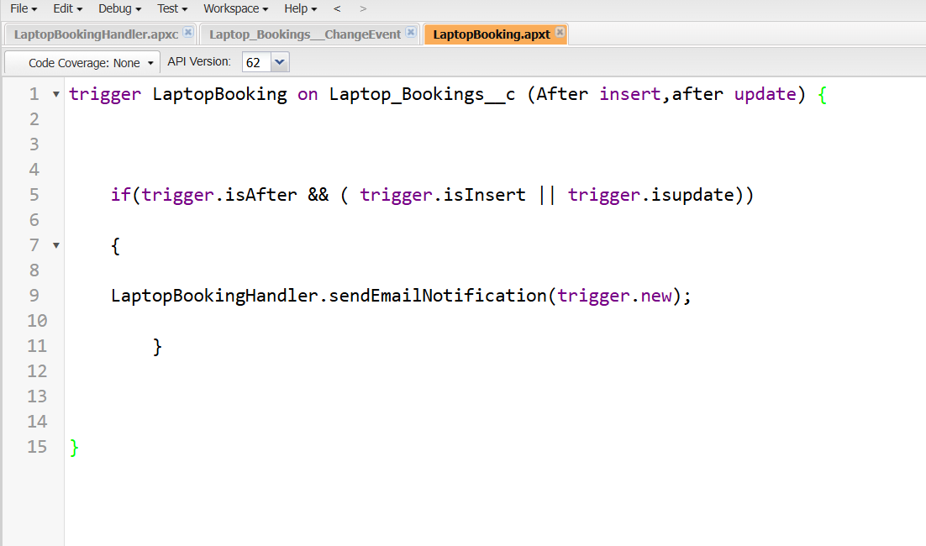

Apex Trigger

* Report : Generates insights and analyzes rental trends.

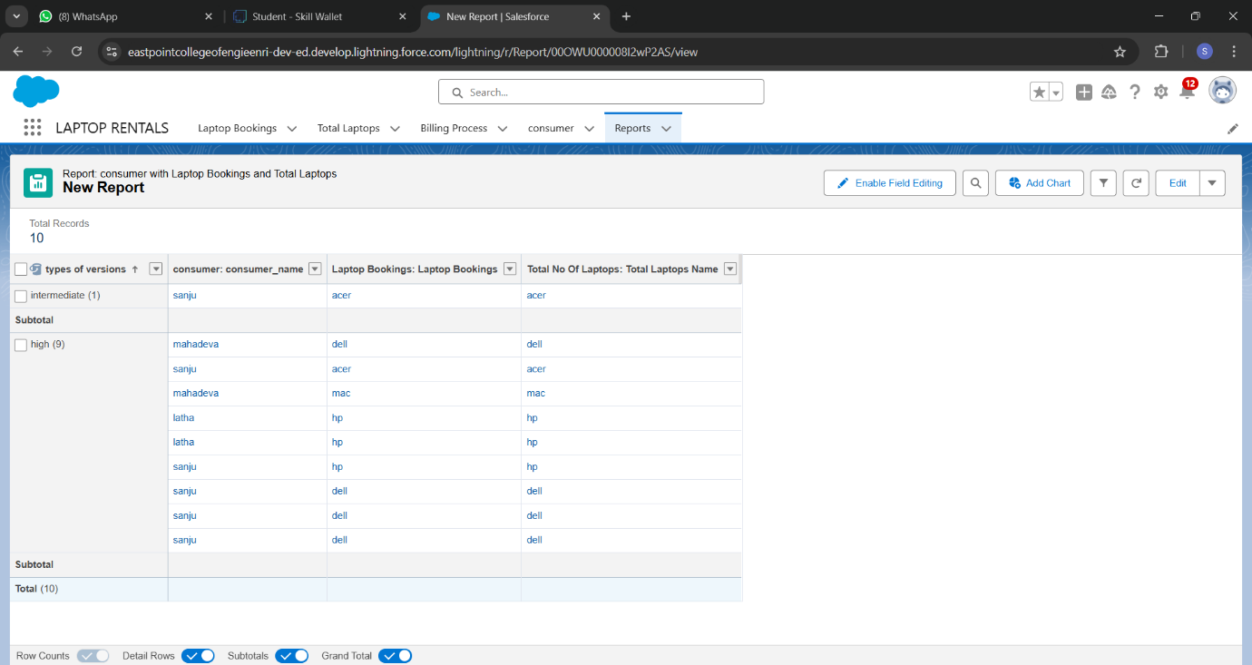

* Dashboard : Visualizes key performance indicators (KPIs) and metrics.

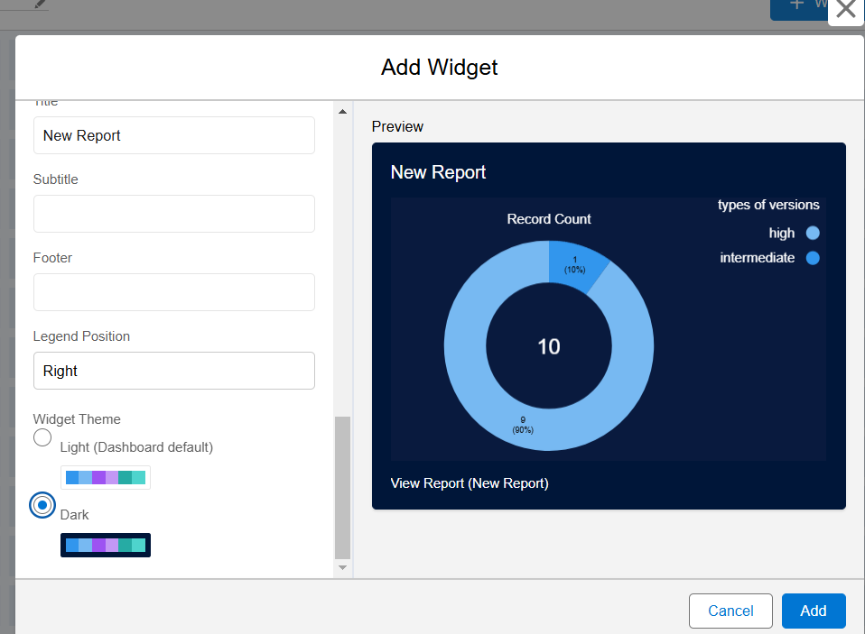

**5. Testing and Validation**

***Unit Testing (Apex Classes, Triggers)***

* Test Classes: Create special test classes in Salesforce to hold all unit tests. These classes help keep tests separate from real data.
* Test Methods: Write specific test methods that set up test data, run the code, and check if the results are what we expect.

***User Interface Testing***

* Manual Testing: Check the user interface manually to ensure all buttons, links, and forms function properly.

**6. Key Scenarios Addressed by Salesforce in the Implementation Project**

* Customer Rental Management: Salesforce effectively manages customer rental information, allowing businesses to track rental history, preferences, and interactions, ensuring personalized service for each customer.
* Automated Booking Process: The platform automates the booking process for laptop rentals, enabling customers to reserve laptops online while streamlining internal operations and reducing manual errors.
* Inventory Tracking: Salesforce helps manage laptop inventory in real-time, allowing users to see available stock, track rentals, and manage returns efficiently to prevent overbooking.
* Email Communication Automation: The system automates email  communications with potential and existing customers, ensuring timely follow-ups and promotional offers to enhance customer engagement.
* Reporting on Rental Trends: Salesforce provides powerful reporting tools that allow the business to analyze rental trends, customer behavior, and operational performance, helping to make informed decisions about inventory and marketing strategies.
* User Role and Permission Management: The application allows for detailed user roles and permissions, ensuring that staff members have appropriate access to sensitive customer data and rental information based on their responsibilities

**7. Conclusion**

* The project has automated the booking and rental management processes, significantly reducing manual errors and improving turnaround times for customer transactions .
* A comprehensive customer database has been established, enabling personalized communication and tailored rental experiences based on individual customer preferences and history.
* The application now provides real-time tracking of laptop availability, ensuring optimal inventory utilization and minimizing the risk of overbooking.
* Automated email notifications and follow-ups have been implemented, improving engagement with potential and existing customers while ensuring timely communication.
* A clear structure for user roles and permissions has been established, ensuring data security and appropriate access control across the organization.